**Task- 1**

**Aim: Create an app as shown in below image.**

**Program:**

import 'package:flutter/material.dart';

void main() {

runApp(

MaterialApp(

debugShowCheckedModeBanner: false,

home: page(),

),

);

}

class page extends StatefulWidget {

@override

_pageState createState() => _pageState();

}

class _pageState extends State<page> {

@override

Widget build(BuildContext context) {

return Scaffold(

backgroundColor: Color(0xffffc107),

appBar: AppBar(

backgroundColor: Colors.black,

title: const Text(

"BOLT",

style: TextStyle(letterSpacing: 19),

),

centerTitle: true,

),

body: Column(

children: [

Expanded(

child: Row(

mainAxisAlignment: MainAxisAlignment.center,

children: [

Container(

height: double.infinity,

width: 100,

color: Colors.black,

child: const Center(

child: Text(

"⚡",

style: TextStyle(color: Color(0XFFffd433), fontSize: 80),

)),

),

],

),

),

],

),

);

}

}

**Output:**

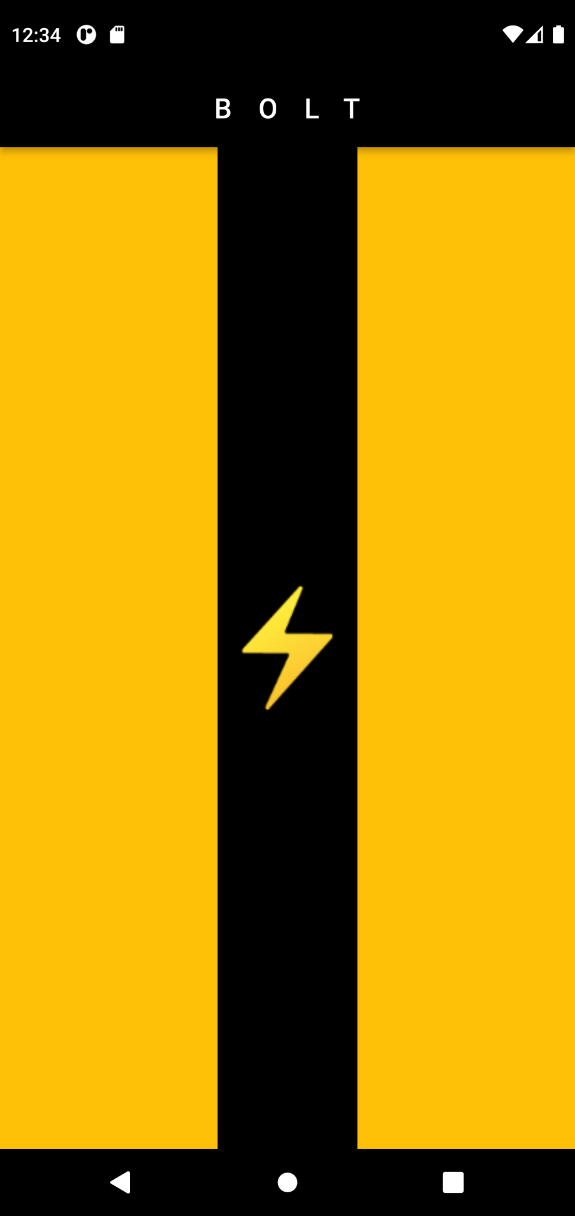

**Task- 2**

**Aim: Create an app as shown in below image.**

**Program:**

import 'package:flutter/material.dart';

void main() {

runApp(

MaterialApp(

debugShowCheckedModeBanner: false,

home: theWall(),

),

);

}

class theWall extends StatefulWidget {

const theWall({Key? key}) : super(key: key);

@override

State<theWall> createState() => _theWallState();

}

class _theWallState extends State<theWall> {

@override

Widget build(BuildContext context) {

return Scaffold(

appBar: AppBar(

backgroundColor: Colors.black,

title: const Text(

"THE WALL",

style: TextStyle(wordSpacing: 1),

),

centerTitle: true,

),

body: Container(

width: double.infinity,

height: double.infinity,

child: SingleChildScrollView(

child: Column(

children: [

Row(

children: [

Container(

margin: const EdgeInsets.only(

top: 10,

right: 8,

),

height: 60,

width: 110,

color: Colors.brown,

),

Container(

margin: const EdgeInsets.only(

top: 10,

right: 8,

),

height: 60,

width: 170,

color: Colors.brown,

),

Container(

margin: const EdgeInsets.only(

top: 10,

right: 0,

),

height: 60,

width: 110,

color: Colors.brown,

),

],

),

Row(

children: [

Container(

margin: EdgeInsets.only(top: 9),

height: 60,

width: 140,

color: Colors.brown,

),

Container(

margin: EdgeInsets.only(top: 9, left: 8),

height: 60,

width: 110,

color: Colors.brown,

),

Container(

margin: EdgeInsets.only(top: 9, left: 8),

height: 60,

width: 140,

color: Colors.brown,

),

],

),

Row(

children: [

Container(

margin: const EdgeInsets.only(

top: 10,

right: 8,

),

height: 60,

width: 110,

color: Colors.brown,

),

Container(

margin: const EdgeInsets.only(

top: 10,

right: 8,

),

height: 60,

width: 170,

color: Colors.brown,

),

Container(

margin: const EdgeInsets.only(

top: 10,

right: 0,

),

height: 60,

width: 110,

color: Colors.brown,

),

],

),

Row(

children: [

Container(

margin: EdgeInsets.only(top: 9),

height: 60,

width: 140,

color: Colors.brown,

),

Container(

margin: EdgeInsets.only(top: 9, left: 8),

height: 60,

width: 110,

color: Colors.brown,

),

Container(

margin: EdgeInsets.only(top: 9, left: 8),

height: 60,

width: 140,

color: Colors.brown,

),

],

),

Row(

children: [

Container(

margin: const EdgeInsets.only(

top: 10,

right: 8,

),

height: 60,

width: 110,

color: Colors.brown,

),

Container(

margin: const EdgeInsets.only(

top: 10,

right: 8,

),

height: 60,

width: 170,

color: Colors.brown,

),

Container(

margin: const EdgeInsets.only(

top: 10,

right: 0,

),

height: 60,

width: 110,

color: Colors.brown,

),

],

),

Row(

children: [

Container(

margin: EdgeInsets.only(top: 9),

height: 60,

width: 140,

color: Colors.brown,

),

Container(

margin: EdgeInsets.only(top: 9, left: 8),

height: 60,

width: 110,

color: Colors.brown,

),

Container(

margin: EdgeInsets.only(top: 9, left: 8),

height: 60,

width: 140,

color: Colors.brown,

),

],

),

Row(

children: [

Container(

margin: const EdgeInsets.only(

top: 10,

right: 8,

),

height: 60,

width: 110,

color: Colors.brown,

),

Container(

margin: const EdgeInsets.only(

top: 10,

right: 8,

),

height: 60,

width: 170,

color: Colors.brown,

),

Container(

margin: const EdgeInsets.only(

top: 10,

right: 0,

),

height: 60,

width: 110,

color: Colors.brown,

),

],

),

Row(

children: [

Container(

margin: EdgeInsets.only(top: 9),

height: 60,

width: 140,

color: Colors.brown,

),

Container(

margin: EdgeInsets.only(top: 9, left: 8),

height: 60,

width: 110,

color: Colors.brown,

),

Container(

margin: EdgeInsets.only(top: 9, left: 8),

height: 60,

width: 140,

color: Colors.brown,

),

],

),

Row(

children: [

Container(

margin: const EdgeInsets.only(

top: 10,

right: 8,

),

height: 60,

width: 110,

color: Colors.brown,

),

Container(

margin: const EdgeInsets.only(

top: 10,

right: 8,

),

height: 60,

width: 170,

color: Colors.brown,

),

Container(

margin: const EdgeInsets.only(

top: 10,

right: 0,

),

height: 60,

width: 110,

color: Colors.brown,

),

],

),

Row(

children: [

Container(

margin: EdgeInsets.only(top: 9),

height: 60,

width: 140,

color: Colors.brown,

),

Container(

margin: EdgeInsets.only(top: 9, left: 8),

height: 60,

width: 110,

color: Colors.brown,

),

Container(

margin: EdgeInsets.only(top: 9, left: 8),

height: 60,

width: 140,

color: Colors.brown,

),

],

),

Row(

children: [

Container(

margin: const EdgeInsets.only(

top: 10,

right: 8,

),

height: 60,

width: 110,

color: Colors.brown,

),

Container(

margin: const EdgeInsets.only(

top: 10,

right: 8,

),

height: 60,

width: 170,

color: Colors.brown,

),

Container(

margin: const EdgeInsets.only(

top: 10,

right: 0,

),

height: 60,

width: 110,

color: Colors.brown,

),

],

),

Row(

children: [

Container(

margin: EdgeInsets.only(top: 9),

height: 60,

width: 140,

color: Colors.brown,

),

Container(

margin: EdgeInsets.only(top: 9, left: 8),

height: 60,

width: 110,

color: Colors.brown,

),

Container(

margin: EdgeInsets.only(top: 9, left: 8),

height: 60,

width: 140,

color: Colors.brown,

),

],

),

],

),

),

),

);

}

}

**Output:**

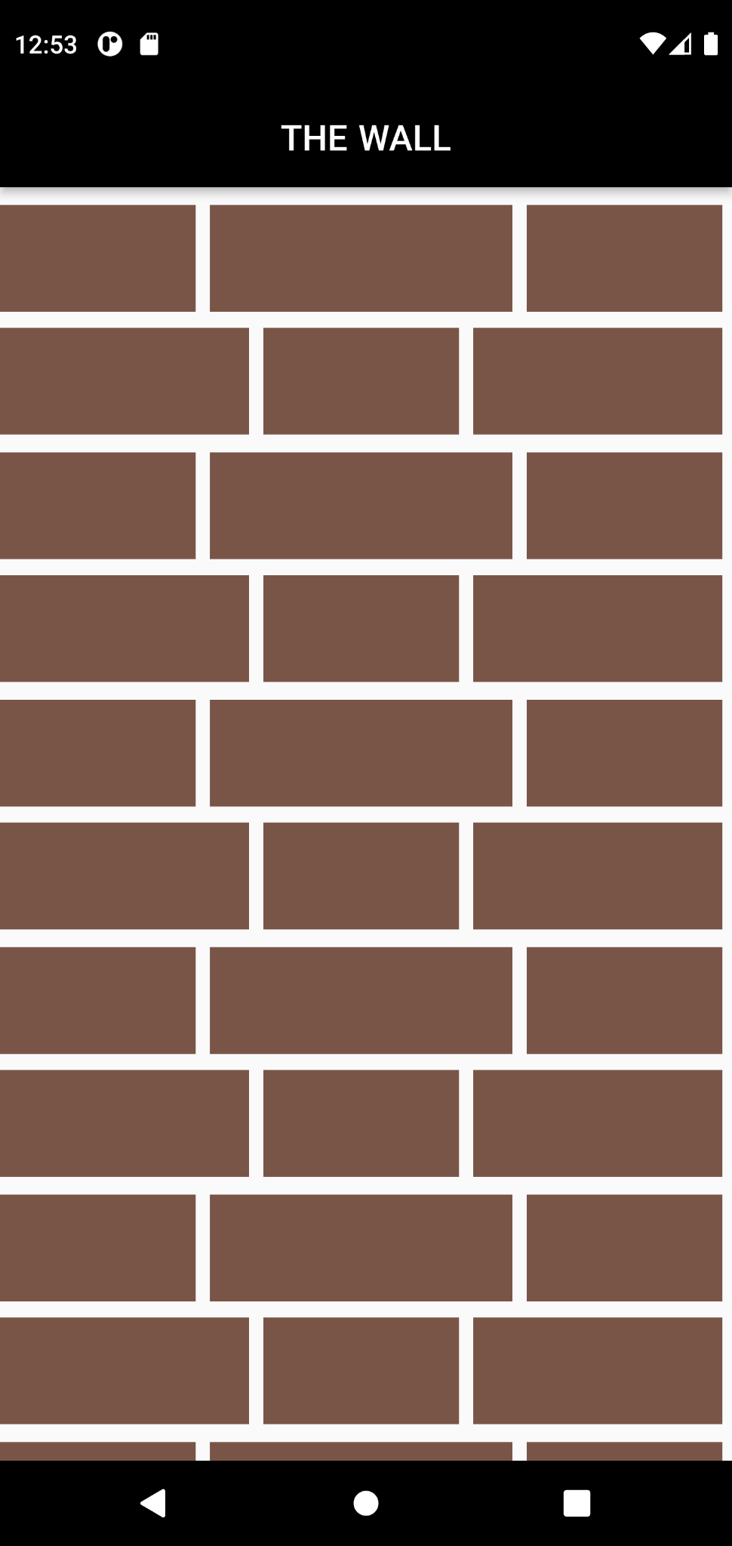

**Task- 3**

**Aim: Create an app as shown in below image.**

**Program:**

import 'package:flutter/material.dart';

void main() {

runApp(

const MaterialApp(

debugShowCheckedModeBanner: false,

home: splitter(),

),

);

}

class splitter extends StatefulWidget {

const splitter({Key? key}) : super(key: key);

@override

State<splitter> createState() => _splitterState();

}

class _splitterState extends State<splitter> {

@override

Widget build(BuildContext context) {

return Scaffold(

backgroundColor: Colors.orangeAccent,

appBar: AppBar(

backgroundColor: Colors.black,

title: Text("SPLITTER"),

centerTitle: true,

),

body: Column(

children: [

Container(

margin: EdgeInsets.all(10),

height: 60,

width: 350,

color: Colors.amberAccent,

child: const Center(

child: Text("1"),

),

),

Container(

margin: EdgeInsets.all(10),

height: 60,

width: 350,

color: Colors.amberAccent,

child: const Center(

child: Text("2"),

),

),

Container(

margin: EdgeInsets.all(10),

height: 60,

width: 350,

color: Colors.amberAccent,

child: const Center(

child: Text("3"),

),

),

Container(

margin: EdgeInsets.all(10),

height: 60,

width: 350,

color: Colors.amberAccent,

child: const Center(

child: Text("4"),

),

),

Expanded(

child: SingleChildScrollView(

scrollDirection: Axis.horizontal,

child: Row(

children: [

Container(

margin: EdgeInsets.all(10),

height: 350,

width: 60,

child: const Center(

child: Text("5"),

),

color: Color(0xff9e9e9e),

),

Container(

margin: EdgeInsets.all(10),

height: 350,

width: 60,

color: Color(0xff9e9e9e),

child: const Center(

child: Text("6"),

),

),

Container(

margin: EdgeInsets.all(10),

height: 350,

width: 60,

color: Color(0xff9e9e9e),

child: const Center(

child: Text("7"),

),

),

Container(

margin: EdgeInsets.all(10),

height: 350,

width: 60,

color: Color(0xff9e9e9e),

child: const Center(

child: Text("8"),

),

),

Container(

margin: EdgeInsets.all(10),

height: 350,

width: 60,

color: Color(0xff9e9e9e),

child: const Center(

child: Text("9"),

),

),

Container(

margin: EdgeInsets.all(10),

height: 350,

width: 60,

color: Color(0xff9e9e9e),

child: const Center(

child: Text("10"),

),

),

],

),

),

),

],

),

);

}

}

**Output:**

